The Dynamics of Message Exposure Online in Political Discussion Forums:

Self-Segregation or Diverse Exposure?

Hyunjin Songa, Jaeho Chob, & Jong Hyuk Leec

a Department of Communication, University of Vienna, Austria

b Department of Communication, UC Davis, USA

c School of Journalism & Mass Communication, Kyung Hee University, South Korea

Hyunjin Song

Rathausstraße 19/1/9

Vienna, 1010

Austria

[hyunjin.song@univie.ac.at](mailto:hyunjin.song@univie.ac.at)

Jaeho Cho

375 Kerr Hall

1 Shields Avenue

Davis, CA 95616

USA

[jaecho@ucdavis.edu](mailto:jaecho@ucdavis.edu)

Jong Hyuk Lee

620 College of politics and economics

26 Kyungheedae-ro, Hoegi-dong, Dongdaemun-gu

Seoul, 02447

South Korea

[jonghhhh@khu.ac.kr](mailto:jonghhhh@khu.ac.kr)

Paper submitted to XXXX

Abstract

**TBA**

*Keyword*: Online political discussion, online discussion forum, message selection and exposure, Temporal exponential random graph model

**The Dynamics of Message Exposure Online in Political Discussion Forums:**

**Self-Segregation or Diverse Exposure?**

Based on the Harbermasian ideal of free and open space for civil society, internet has long been regarded as the pivotal space in which a diverse group of individuals connect each other and voluntarily participate in everyday political processes (Papacharissi, 2004; Stromer-Galley, 2003; Wojcieszak & Mutz, 2009). Internet space is believed to expose individuals to a wider array of viewpoints and perspective, fostering the quality and richness of citizen deliberation (Dahlgren, 2005). Yet this view of internet space as “a free and open space for civil society” (Himelboim, 2011, p. 634) has been increasingly contested by many critics.

While the question of how exactly internet has changed the landscape of everyday cross-cutting exposure is still an open question to address, online discussion forum in particular represent a situation that is relatively free from contextual constrains (Dahlgren, 2005), where individual’s purposive choices regarding information that they choose to encounter and whom they choose to associate with fellow citizens are relatively maximized. Correspondingly, there has been a widespread worry about self-reinforcing online political echo chambers (e.g., Sunstein, 2009) afforded by digital tools that help filter out unwanted viewpoints from one’s own (Dylko, 2016). Parallel with the observation that self-selected partisan homogeneity in one’s day-to-day information diet (Iyengar & Hahn, 2009) and in offline social network composition (Iyengar & Westwood, 2015) is increasing, a similar speculation of increasing political homogeneity in online social networks has been repeatedly raised by many scholars (e.g., Boutyline & Willer, 2017; Colleoni et al., 2014; Sunstein, 2009). Yet, empirical endeavors to examine this question have produced mixed findings at best (e.g., Gentzkow & Shapiro, 2011; Messing & Westwood, 2012), and therefore the exact nature and its etiology of partisan homogeneity online is not yet clearly understood.

With unprecedented choices of what to discuss and whom to interact with within an online setting, do these choices lead to cross-cutting exposure across ideological divides or inevitably lead to increasing polarization driven by political homophily? In this paper, we attempt to advance our understanding on this debate by focusing on *message selection dynamics* in online discussion forum. Although a great progress has been made, much of the prior work on this topic has primarily based on participants’ retrospective self-reports (Stromer-Galley, 2003; Wojcieszak & Mutz, 2009), or at best solely based on observable posted messages (e.g., Himelboim, 2008; 2011) and written communication relations (e.g., Boutyline & Willer, 2017; Colleoni et al., 2014; Graham & Wright, 2014). As a consequence, there has been a lack of systematic investigation as to individuals’ exposure decisions at first place – whether one chooses to *read* a given message in a forum – even before choose to react and reply to a given message. This oversight is particularly troubling, since the proper identification of impact of political homophily on cross-cutting *exposure* online, we argue, requires not only information between visibly connected dyads (i.e., post – reply relation in a given dyad) but also critically hinges on information between unconnected dyads (i.e., one’s messages were not received by others, or alternatively they do not further interact despite one’s messages are received). Since typical retrospective self-reports or content-only based examination cannot answer such a question, it precludes a meaningful assessment of impact of political preferences in producing balanced *exposure* online.

Instead of assessing the extent of political homogeneity solely based on written messages, we instead focus our attention to individuals’ underlying motives and mechanisms that drives one’s message “reception” decisions regarding his or her interactions with fellow citizens, and how such underlying dynamics would manifest themselves through individuals’ message exposure patterns using novel behavioral log data matched with network panel survey responses. Our goal is to identify whether, and how, citizen’s free and voluntary interactions – as a form of reading one another’s messages in an online discussion forum – result from a purposive pursuit for political similarity, or instead propelled by other motivations and structural features of discussion settings itself, which is largely incidental to overt political preferences. In what follows, we first briefly review underlying motivational and structural factors that drive citizen’s everyday discussion with fellow citizens. We emphasize two motivational underpinnings – *consistency* and *understanding* – as the two motivational drivers of online political discussion (and therefore so do behaviors of individuals), and ultimately, the recursive impact of structures of online discussion itself in shaping individual’s exposure decisions. We then offer empirical assessment using novel longitudinal network panel data matched with survey responses and behavioral log data, demonstrating that the impact of overt political preferences in shaping one’s exposure decisions (i.e., choose to view other’s messages) are much limited than it often assumed.

**Two Motivational Drivers of Political Discussion: Consistency and Understanding**

From the perspective of the cognitive consistency, individuals are more likely to choose to view a message that conforms their priors (McPherson, Smith-Lovin, & Cook, 2001; Iyengar & Hahn, 2009). This notion of homophily, or the tendency of a given dyad to associate with each other based on their similarities, has long been regarded as a powerful determinant of message exposure decision (Garrett & Stroud, 2014; Iyengar & Hahn, 2009; Song, 2015). Based on this premise, we generally predict that those who have higher consistency motivations, or those who prefer to view messages that align their prior attitudes, are more likely to disproportonately seek out messages written by fellow partisans. Yet, recent advance in this topic suggest that partisans with high consistency motivation are not necessarily “avoid” potentially dissonant messages (Garrett, 2009; Garrett & Stroud, 2014). This leads us to expect that higher consistency motivation is associated with higher level of information seeking behavior, irrespective of messages’ congeniality. At the same time, it is also expected that their messages are more likely to *be selected by others*, presumably since those with high consistency motivation communicate clear, strong partisan messages (Ahn, Huckfeldt, & Ryan, 2014). These two expectations culminate to our first set of hypotheses:

**H1a**: Consistency motivation is positively associated with the propensity of one’s messages being selected and read by others in the online discussion forum.

**H1b**: Consistency motivation is positively associated with one’s propensity of selecting others’ messages in the online discussion forum.

Contrary to cognitive consistency, understanding motivation – the idea that people are motivated to accurately make sense of outside world – presents another angle of which we can investigate why people choose to expose themselves to particular messages (Holbert, Weeks, & Esralew, 2013). This perspective posits that people desire to accurately perceive a phenomenon in question, seek out correct information, and process relevant messages in a relatively unbiased, evenly manner (Holbert et al., 2013). From this angle, those with higher understanding motivation are likely to seek out and carefully processing relevant information, similar to the findings that need for cognition positively predict a host of information seeking behaviors (Cacioppo et al., 1996). Yet compared to consistency motivation, those with higher understanding motivations are less likely to clearly communicate partisan messages, let alone they are less expressive of their viewpoints. Therefore, they are less likely to be selected by others compared to those with higher consistency motivation. Formally, we expect:

**H2a**: Understanding motivation is negatively associated with the propensity of one’s messages being selected and read by others in the online discussion forum.

**H2b**: Understanding motivation is positively associated with one’s propensity of selecting others’ messages in the online discussion forum.

In addition to consistency and understanding, hedonic motivation – or an idea that people seek to gain pleasure and enjoyment – is another important motivational underpinning of why people use media and interact with each other (Holbert et al., 2013). For the current context, it is plausible to assume that those who found using online discussion forum and interacting with others more pleasurable and enjoyable would be generally inclined to be remain active and more participatory than otherwise. Yet while it is expected that those with higher hedonic motivations to be more active (i.e., more likely to view others’ messages and engage with others), it is not entirely clear whether and how such hedonic motivation is related to the propensity of *being selected by others*. Therefore, we simply expect following:

**H3**: Hedonic motivation is positively associated with the propensity of selecting others’ messages in the online discussion forum.

**Impact of Homophily at Dyadic Level**

The cognitive consistency principle further leads us to hypothesize a positive impact of partisan preference homophily in their message selection dynamics. Either based on an explicit application of political preferences or based on de facto preference homophily based on other similar characteristics, research has repeatedly suggested that people can selectively construct their social environment around them (Kossinets & Watts, 2009; Lazer et al., 2010; McPherson et al., 2001). Within the present context, this mean an ego (“focal respondent”) and alters (“potential discussion partner”) are more likely to select each other’s messages if they share same political preferences. Therefore, we posit that:

**H4**: Same candidate preference (H4a) and similar policy preference (H4b) within a dyad increase the propensity of selecting each other’s messages.

In addition, we expect voters of similar candidate evaluation criteria are more likely to select each other’s message, irrespective of their congeniality towards their initial preference. Based on understanding principle, this is based on the expectation that such information is of high utility to make relevant judgments regarding whom they should (or should not) support for. Prior literature agrees while voters actively glean relevant information from their social networks, they also appear to value political expertise more than shared preferences (Ahn et al., 2014). Hart et al.’s (2009) research, for instance, have found that disconfirmation bias is substantially reduced when encountered with messages of higher informational value. Since messages that are similar in terms of judgmental criteria (on which others make candidate evaluations) may contain highly relevant information and signal utilities, voters are more likely than otherwise to select such messages – especially when they are motivated to make accurate evaluations towards political candidate. Formally:

**H5**: Similarity in candidate evaluation criteria is positively associated with the propensity of selecting each other’s messages in the online discussion forum.

**Endogenous Impact of Network Structure**

*Reciprocity.* Often in online discussion forums, users not only intentionally seek for certain information, but they also spontaneously exchange, respond, and react to others’ opinions and messages. This presumably may take a number of possible forms such as providing simple feedback cues (“likes” or “dislikes”), recommend such posts to others, and leaving a comment, etc. Yet the most simple and frequent form of such “interaction” may manifest as continuous, interactive “discussion thread” – message exchange sequences – among a set of members. This also implies that such interaction patterns may have create a situation of which an actor *i* and actor *j* mutually choose to view each other’s messages, direct and return their attentions to each other – provided that leaving a reply or comments to an original message necessitate a responder to actually click and read that message at first place. Based on this expectation, we hypothesize that reciprocity, or the extent of which the relationships between actors in a social network are symmetric (Wasserman & Faust, 1994), would be one of the significant and positive predictor of presence of ties within an online discussion network:

**H6**: There would be more than expected by chance likelihood of reciprocity in message selection pattern within a dyad.

*Transitivity, cyclic closure, and local hierarchy.* Transitivity and cyclic closure may represent another fundamental social process of which how individuals select which messages to read, determining the overall message exposure patterns online. The concept of transitivity, or “triadic closure,” denotes situation where nodes *i* is more likely than chance to form a relation to another node *j* when they are connected to *k* other nodes (Holland & Leinhardt, 1976). In contrast, cyclic closure denotes similar situation for node *j* to form a tie to node *i* when they are connected to *k* other nodes, as can be seen in Table 1 below.

It is worth noting that transitive closure can signify several different underlying mechanisms of which one can select potential alters in social network; While the most common explanation for transitive closure is that it reflects a local spread of social relations (e.g., “friends of my friends are my friends”), such a pattern also reflects the closure of structural hole, in that node *i* circumvents brokerage role of other node *k* in reaching out another node *j* (e.g., Carpenter, Esterling, & Lazer, 2004). Another, equally plausible possibility is that a tendency for transitivity reflects a hierarchical nature of a given network, such that node *i* would seek to create a tie towards a higher status node *j* given the exiting relations with intermediate-status node *k*. Coupled with negative tendency towards cyclic closure (e.g., *j* is less likely to form a tie to low status individual *i* despite the positive tendency of *i* to form a tie *j*), such pattern can be interpreted as the lack of generalized exchange due to local status hierarchy in a given network (Lazega et al., 2012).

It is important to nothing that, within the context of “message selection” dynamics in an online political discussion forum, the information of whether or not *k* has chosen to view *j*’s messages is not available to *i* when *i* choose to view *j*’s messages (unless such information is explicitly visible via some functionalities in the system). Therefore, it is somewhat less likely that transitivity would reflect local spreads of social relationship, which requires actors to be aware of others’ social relationship in choosing others to interact. Within the context of predicting triadic configuration, it is therefore more plausible to assume that transitivity patterns arise from the hierarchical nature of underlying criteria in which people choose each other’s messages. Indeed, it is well documented that people’s political expertise level is not evenly distributed (Delli Carpini & Keeter, 1996; Verba, Schlozman, & Brady, 1995), and people routinely rely on and seek guidance from those who are more politically attentive and knowledgeable (Downs, 1957; Huckfeldt, 2001; McClurg, 2006). Therefore, one possible source of such hierarchical organization of network structure can be an individual’s need for having political experts around and choose to view messages of those local experts. Assuming the underlying tie-generative process is indeed driven by such substantive interests, it is conceivable that the uneven level of political expertise within a triad would be manifested via a hierarchically organized message selection dynamic. Therefore:

**H7a**: There would be more than expected by chance likelihood of transitive closure in message selection pattern among set of three actors.

**H7b**: There would be less than expected by chance likelihood of cyclic closure in message selection pattern among set of three actors.

*Structural equivalence and profile similarity.* Another important local configuration that help us understand the nature of message selection dynamics in online forums is the concept of structural equivalence and profile similarity. In addition to the hierarchical nature of underlying criteria in which people choose each other’s messages, they choose to interact with each other because they both connected to the same way to other actors in the network. That is, similar to the notion of structural equivalence, they maintain similar pattern of connections to all other actors in the network, such that they choose to view messages from the many same alters (“activity closure”), or they are chosen by same many alters (“popularity closure”: see Table 1 below for the respective diagram), which signals the common properties of a given dyads (Block & Grund, 2014; Robins et al., 2009). This may be viewed as structural bases of homophily, where the formation of ties is driven by similarity in choices with respect to other actors (DiMaggio, 1986). Therefore, we expect:

**H8a**: There would be more than expected by chance likelihood of activity closure in message selection pattern among set of three actors.

**H8b**: There would be more than expected by chance likelihood of popularity closure in message selection pattern among set of three actors.

*Preferential attachment.* Several studies indicate that a structure of large, online social network tends to follow power-law distribution. While the existence of skewed degree distribution is rather common (Barabási & Albert, 1999; Snijders, 2011), it appears that such tendencies are more pronounced in online context. For instance, Himelboim’s (2008; 2011) analysis suggests a sharp inequality in ability to draw attention and elicit further engagement with a given message from a large number of users in online discussion groups. Within an online discussion forum, one often employs certain heuristic cues such as the number of “views” and “likes” in selecting which messages to click, which signals utility based on popularity of a message. Therefore, a message that has large number of engagement cues (such as views or likes) can draw disproportionate reactions by its self-reinforcing dynamics, leading to highly imbalanced distribution of message selections. Therefore, we expect:

**H9**: There would be more than expected by chance likelihood of selecting messages when such messages are *already* selected by a large number of others.

**Temporal Dynamics in Message Selection Criteria**

As elections near, it is reasonable to believe that individuals are more mobilized by campaign communication (Cho, 2013; Holbrook & McClurg, 2005), hence are expected to pay close attention to political messages both in online and offline. Not only a heightened attention to politics in general more likely to make them to do so, but they also may need more information to reduce uncertainties or anxieties regarding their decisions as the election day approaches (Downs, 1957). While literature generally suggests that strong partisans and interested voters arrive their decisions early in the election campaign cycle (Fournier, Nadeau, Blais, Gidengil & Nevitte, 2004), the nature and extent of changes in campaign environment (e.g., campaign competitiveness) may prompt even strong partisans to seek out confirmatory information. Specifically, increases in uncertainty regarding the ultimate consequences of election outcome may further propel confirmatory information seeking behavior (Carnahan, Garrett, & Lynch, 2016; Valentino et al., 2009). Literature also suggests if there’s no reason to believe counter-attitudinal information is useful for reducing decision-related uncertainty and anxiety, then individuals are more expected to rely on confirmatory evidence (Valentino et al., 2009). To the extent that changes in campaign environment (e.g., campaign competitiveness) *over time* induce more anxiety and uncertainty regarding the election outcome, this further suggests that the effect of preference homophily may increase rather than being constant over time. Therefore:

**H10**: The effect of preference homophily in message selection increases over time.

**Data and Methods**

In order to test our predictions, we draw a unique set of whole network panel with survey responses collected during the 2012 South Korean presidential election. The data were collected from an online discussion forum hosted on research firm’s server where participants’ posting and viewing activities during 27 day-period until Election day (from November 23 to December 19, 2012) is unobtrusively logged. A market research firm invited 400 participants from a nationally representative panel, of which a total of 334 participants remained on the discussion forum and completed three waves of panel surveys. Surveys measured participants’ candidate evaluations and its criteria, policy preferences, motivations for using the online discussion forum, and other key covariates of interest. Participants were instructed to freely post and read each other’s opinions regarding upcoming election as they normally would in other online forums in return for a monetary incentive of $100. Activity log data regarding participants’ message viewing and posting activities were later retrieved from the research firm’s computer server and matched with participants’ survey responses.

At the start of the wave 1 survey, 22 participants (6.5%) out of all 334 participants did not initially identify their candidate preference nor had favored one of two major candidates based on relative thermometer ratings. Since we control for actors’ candidate choices and regard candidate preference homophily as a key predictor in our model, we limit the analysis to those with known candidate choices across all three survey waves (*N* = 312).[1]

**Construction of Networks and Analysis Strategy**

Based on activity log of participants’ message browsing behaviors, we derive a “message exposure” network as a directed actor-actor binary matrix (312 x 312), such that the cell entry X*ij* is defined as 1 when actor *i* chooses to view actor *j*’s message and zero for otherwise. Based on the dates of three panel survey responses (W1 = Nov 27th to 29th, W2 = Dec 11th to 13th, W3 = after the election day, which was Dec 19th, 2012), we partition log data in a way that it closely matches with survey dates in creating a longitudinal panel series of message exposure networks (e.g., log data from Nov 27th to 29th were regarded as the 1st wave of the network panel), except for the last wave of the network panel. Since the 3rd wave of the survey was conducted *after* the election day whereas electronic log data were collected *only until* the election day, we regard the last three days of log data (Dec 17th to 19th) as the last panel in network.[2] In addition, since the log data were available from November 23rd, the log data *before* the first wave of panel survey (Nov 27th) or *between* each survey waves were regarded as lagged observation of the respective network panel. Specifically, we treat data from Nov 23rd to 26th as the lagged observations of the first network while treating data from Nov 27th to 29th as the 1st wave of the network. Likewise, log data from Nov 30th to Dec 10th constitute lagged observation of the second network (Dec 11th to 13th) while log data from Dec 14th to 16th constitute lagged observation of the last network (Dec 17th to 19th).[3]

**Measures**

**Motivations for using online discussion forum.** For consistency motivation (Cronbach’s α = .86, *M* = 4.36, *SD* = 1.03), respondents were asked six items (based on a 7-point scale from “Not at all” = 1 to “Very much” = 7) whether they visit online discussion forums (including discussion forums other than current study) primarily “to justify my opinion of the issue” or “to confirm that my opinion on the issue is correct.” Understanding motivations (α = .81, *M* = 5.26, *SD* = .82) and hedonic motivations (α = .75, *M* = 4.47, *SD* = 1.04) were assessed in a similar manner, respectively using four (e.g., “to make an accurate and objective assessment of the issue”) and three items (e.g., “it is interesting and fun”).

**Preference homophily**. We define three different measures of political preference homophily based on (a) candidate choice, (b) policy preference, and (c) candidate evaluative criteria. First, a candidate preference homophily was defined in a way that a tie was identified as homophilous (coded as “1”) if a given dyad shares the same candidate preference (“1” supporting liberal candidate, Moon Jae-in, vs. “0” supporting conservative candidate, Park Geun-hye; W1: *M* = .60, *SD* = .49; W2: *M* = .66, *SD* = .47; W3: *M* = .61, *SD* = .48). Next, policy preference homophily (W1: *M* = .40, *SD* = .16; W2: *M* = .38, *SD* = .16; W3: *M* = .39, *SD* = .16, all range = 0 to 1) was operationalized based on respondents’ dyadic Euclidean distance, *d*, out of liberal vs. conservative oriented policy preferences towards economic and North Korea issues. Policy preferences were measured three times across panel surveys, and respective Euclidean distances were later converted to similarity measures by taking 1 / (1 + *d*), so that a greater value of the similarity would represent higher preference homophily. Lastly, we define candidate evaluation criteria homophily (*M* = .48. *SD* = .15, range = 0 to 1) in a similar manner, 1 / (1 + *d*), using a dyadic Euclidean distance *d* in terms of relative importance of competence/impression (e.g., policy, competence, or perceived personal characters such as integrity) versus personal background (e.g., party affiliation, political career, place of origin, etc.) in candidate evaluations. Since candidate evaluative criteria was measured only at Wave 1 survey, we regard this measure to be invariant across waves.

**Network-endogenous measures.** Reciprocity of message selection relation was measured by whether a pair of actors had mutual “selection” ties with each other. For measures tapping a series of triadic configurations (transitive closure, cyclic closure, activity closure, and popularity closure: see Figure 1 for details), we rely on *directed* version of the geometrically weighted edgewise shared partner (directed GWESP) statistics following the model specifications proposed by Snijders et al. (2006) and Robins et al. (2007). The GWESP term models a linear combination of an entire distribution of directed triangles (*i, h, j*) for a given connected dyad (*i, j*) in the network, and this effect of the triangle distribution is *weighted to produce a decreasing return* following a decay parameter (for a detailed discussion of this measure, see Hunter & Handcock, 2006). As described above, our theory suggests that a series of triadic closure patterns would have a substantial effect on message selection dynamics. Similarly, for measuring activity spread and popularity spread, geometrically weighted out-degree and in-degree distribution (GWD-out and GWD-in) terms were used where the parameter estimates for GWD terms represent “evenness” of in- and out-degree based on message selection activities across the network (for details see Hunter, 2007). We expect these terms to be significantly and highly negative, which signify differential message selection activities across the network.

**Control variables.** In addition to focal predictor variables, we control for a host of variables that are known to be related to the extent of political discussion in order to establish a plausible baseline in our analysis. First, we control for participants’ sociodemographic factors, including *gender* (1 *being* “female,” 48.39%), *age* (in 10-year increment, *M* = 3.55, *SD* = .98), *education* (from “not finished elementary school” = 1 to “currently in post-graduate education or more” = 9, *M* = 7.71, *SD* = .97) and *region of origin* (1 being “Seoul” vs. 0 being “other regions”, 40.38% from Seoul). In our analysis, we also control for two demographic homophily variables, one based on their gender and the other based on their regional origin (all coded as 1 if a dyad share same gender or same regional origin) since demographic homophily may be confounded with respondents’ candidate preference homophily (McPherson et al., 2000). We also control for respondents’ offline discussion frequency (from “Never” = 1 to “Always” = 7, W1: *M* = 4.50, *SD* = 1.04; W2: *M* = 4.62, *SD* = 1.18; W3: *M* = 4.82, *SD* = 1.17), media use frequency (measured in hours, W1: *M* = .76, *SD* = .42; W2: *M* = 1.56, *SD* = 1.66; W3: *M* = 1.65, *SD* = 2.32), and internal discussion efficacy (from “Not at all agree” = 1 to “Strongly agree” = 7, *M* = 4.72, *SD* = .98). Media use frequency was defined as the average hour of exposure to internet news, newspaper and television news exposure regarding the upcoming election, and internal discussion efficacy were gauged using a four-item composite measure tapping how competent and efficacious an individual is in typical political discussion settings.[4]

**Analysis Strategy**

Since we aim to properly capture and explain substantive interdependency dynamics over time, we modeled longitudinally observed message selection networks using a Temporal Exponential Random Graph Model (TERGM), a time-series extension of the ERGM framework with bootstrapping resampling technique as described in Desmarais and Cranmer (2012). The integral part of this approach is to regard the ties in a given network to be a random variable (1 for existence of ties, and zero for otherwise) to be explained simultaneously by a collection of actor covariates and network-endogenous dependencies (Robins et al., 2007; Snijders et al., 2006) while properly account for the non-independence of observations inherent in network data. The ERGM framework is now regarded as the most versatile yet flexible method for evaluating underlying generative properties of a network, as exemplified in recent applications of the method to various domains (Cranmer et al., 2017).

Since our analytical strategy requires all cell entries are defined as binary, we opted for dichotomizing multiple number of selection instances within a same dyad by employing mean number of message selection instances across all dyadic pairs as a threshold. Therefore, our model only speaks to relatively routine, repeated message selection dynamics in a given network panel rather than entire message selection dynamics including accidental, spontaneous selection behaviors. Also, in applying a longitudinal inferential network analysis technique, we also regard observation at a given time point is dependent only upon the previous state of the network (i.e. lagged observation). In capturing temporal dependencies, we include series of lagged endogenous network statistics which might be relevant in messages selection behaviors as additional control variables, along with few additional endogenous network statistics (such as *isolates* and *two-paths*) in order to control temporal or lower-order effects in estimating the effect of key parameters. Details on the applied models are provided in the Appendix. Table 1 below summarize key model terms included in our analysis, with their graphical depiction and substantive interpretation of the effects.

[Table 1 About Here]

Once models were fitted, we assessed goodness-of-fit (*gof*) to identify the model adequacy by simulating nine hundred new networks (three hundred new networks for each time step) and compare the network characteristics from the observed vs. simulated networks (Hunter, Goodreau, & Handcock, 2008). The *gof* results indicate that model specification is satisfactory (see Appedix for details). All analyses were based on maximum pseudo-likelihood estimation with bootstrapped confidence intervals (Desmarais & Cranmer, 2012), as implemented in the *btergm* package in R (Leifeld, Cranmer, & Desmarais, 2017).

**Results**

Table 2 below reports the estimated parameters from the final TERGM specifications along with its 95% confidence intervals (based on bias-corrected and accelerated CIs using 1000 replications, with significant results being bolded), and this is also graphically reported in Figure 1 below (full results are available upon request). Relevant to our main interest, the leftmost model specification (“Final Model” in Table 2) includes the effects of motivation and homophily while properly controlling for hypothesized network structural influence, while a series of interaction models from 2nd to 4th columns test whether the effects of various preference homophily terms increases over time. Across all models, coefficients can be interpreted as log odds of a tie conditional on the rest of the network and other model terms.

[ Table 2, Figure 1 and 2 About Here]

Our first set of hypotheses posit that messages written by individuals with certain motivations are more likely to be selected by others (H1a & H2a), as well as such individuals are more likely to select others’ messages (H1b, H2b & H3). We found mixed support for these expectations, with some of the hypothesized effects fell short of significance level although all of the coefficients were in line with the hypothesized direction. For the final model specification, we found the effect of consistency motivation being nonsignificant in predicting outgoing selection instances (“select others’ messages”: *b* = .025, 95% bootstrap CI = [−.044, .077]), so as to understanding motivations predicting incoming selection instances (*b* = −.052, [−.080, .022]). In contrast, we found a weak but significant tendency for consistency motivation predicting in-ties (*b* = .034, [.009, .113]) and understanding motivation predicting out-going ties (*b* = .028, [.005, .076]), supporting H1a and H2b. Empirical patterns indicate that those who pursue to better understand the outside world are more likely to select and read others’ messages in online discussion forums (compared to those who are low on understanding motivations), while on average people are more likely to select and read messages written by those with higher consistency motivation. In addition to those findings, hedonic motivation is found to be significantly and positively related to outgoing message selection instances (*b* = .102, [.087, .133]), supporting H3.

Concerning our dyadic-level homophily variables, neither candidate preference (H4a: *b* = −.032, [−.070, .047]) nor ideological policy preference homophily (H4b: *b* = −.108, [−.212, .006]) found to be related to the message selection instances, fail to confirm H4. Such null effects of two preference homophily terms indicate that consistency-driven dynamics (i.e., whether one shares same candidate preference or ideological policy preference) is not likely to be related to whether people choose to select and view each other’s messages. Instead, we have found consistent and quite substantial effect of candidate evaluative criteria similarity, such that the more similar a dyad in terms of their candidate evaluative criteria, the more they likely are to expose themselves to another’s messages (H5: *b* = .407, [.399, .415]). We return to the implications of this finding in the discussion section.

Our next set of hypotheses concerns endogenous structural effects of network itself. As shown in Table 2, we have found consistent and robust support for these predictions, such that reciprocity (H6: *b* = .768, [.560, 1.068]), multiple cyclic closure (H7b: *b* = −.066, [−.076, −.061]), multiple activity closure (H8a: *b* = .035, [.033, .043]), multiple popularity closure (H8b: *b* = .113, [.083, .232]), and preferential attachment (*Popularity spread*, H9: *b* = −4.123, [−5.343, −3.541]) were all strongly supported, controlling for the tendency for not having any ties (*isolates*: *b* = 1.003), open triad without closing a triad (*multiple two-path*: *b* = .003, all CIs straddle zero), temporal dependencies, and other motivation and homophily terms.

Among estimated effects, notably the effect of preferential attachment (or uneven degree distribution) was the strongest and substantial, as the negative incoming degree distribution parameter indicates (H9: *b* = −4.123). Figure 2 gives substantive interpretation of the effect, such that predicted probabilities of receiving at least one additional message selection tie (excluding ties that are already connected) from other participants in the forum sharply increases as a function of existing in-degree of a node, irrespective of time periods. This suggests that messages selection dynamics are largely based on self-organizing dynamics, consistent with the notion that people are disproportionately drawn upon and more likely to expose themselves to already popular messages in a forum (Himelboim, 2008).

In addition to the effect of preferential attachment, participants in the online forum are approximately 2 times (*reciprocity*, conditional odds ratio = 2.15) more likely to read potential alter’s message if that alter were already have read his or her message. Likewise, an individual (ego) is approximately 4 to 12 percent more likely to read another participant’s (alter) message for every one person increase in number of other participant that ego and alter are both tied to based on outgoing (*multiple activity closure*: conditional OR = 1.035) or incoming connection patterns (*multiple popularity closure*: conditional OR = 1.121). This suggests that when message selection patterns signal latent shared characteristics between a dyad, they are more likely to select each other’s message. Participants in our online forum were also slightly less likely to form a closed three-cycle, suggesting the network has a slight tendency against generalized exchange that returns to a lower status individuals. The only exception for this pattern was the multiple path closure term (H7a: *b* = .057, [−.053, .094]), although the direction of the effect was again in the expected direction.

Our last hypotheses predicted that as the election approaches, the impact of preference homophily in predicting message selection dynamics would be increased. Among tested interaction terms, only candidate preference homophily is found to significantly interact with time trends (Interaction model I: *b*interaction = .051, [.038, .071]). Specifically, the effect of candidate preference homophily is found to be linearly increasing over time, in a way that message selection among a dyad that share the same candidate preference is more likely as the later in the election period, as plotted in Figure 3. Panel B of the Figure 3 gives Johnson-Neyman regions of significance as a function of time trends, additionally revealing that there is indeed a preference *towards heterophily* earlier in the election (as indicated in conditional main effect: *b* = −.135, [−.211, −.111]) but this effect gradually disappears as the preference towards same candidate choice increases. No other interaction terms emerged as significant.

[ Figure 3 About Here]

**Discussion and Conclusion**

While prior literature has emphasized the deliberative potentials of online discussions (Papacharissi, 2004; Stromer-Galley, 2003), a worry about self-reinforcing political echo chambers is not uncommon to find in extant literature. While the debate whether or not online settings would promote more diverse and balanced exposure to political information is far from being resolved (Dylko, 2016; Garrett, 2009), a more comprehensive understanding of the underlying motivational and structural factors that drive citizen’s everyday discussion with fellow citizens is extremely important, let alone political conversation does serve as an important motivation for further information seeking and participatory behaviors (McClurg, 2006). Against this background, we emphasized consistency and understanding as the two motivational driver of political discussion online, as well as highlighted the role of various preference homophily and endogenous structural factors that stem from the patterns of online discussion itself as the crucial determinants of message selection dynamics. This contribution is among the first to provide more direct evidence disentangling various determinants of message exposure decisions in an online discussion setting. Our findings suggest that while there is some modest tendency based on *both* consistency and understanding motivations, the impact of *overt* partisan preference (as measured by candidate preference homophily and policy preference homophily) was rather limited. Rather, we have observed robust and consistent effects of various endogenous structural factors, coupled with a non-trivial degree of message selection based on similarity of one’s candidate evaluative criteria. This yields significant new insights and add important nuance to our understandings as to how people choose to expose themselves to what contents in online discussion settings.

While some of our initial expectations regarding one’s motivations have received mixed supports, we have found that those with higher understanding motivation to be active in seeking out and expose themselves to messages provided by others. At the same time, those on high consistency motivations are more likely to be the *target* of such message selection dynamics (i.e., their messages are more likely to be selected by others). In contrast, it was not necessarily the case that those with higher consistency motivations are more likely to seek out – presumably confirmatory – information. If it had been significant, it would have indicated that those with higher consistency motivations are presumably seeking out and are sought by mostly like-minded individuals, providing a support for the notion (albeit indirectly) that online settings primarily promote strong selective exposure tendencies. However, our results are more in line with Garrett (2009; also see Garrett et al., 2013) or Bakshy et al. (2015), where more balanced exposure is common than it often assumed. While our results also show that a preference towards opinion-reinforcing information (as shown in significant effect of consistency motivation predicting *incoming* ties) is real, yet this does not necessarily being associated with people *only* seeking out confirmatory information.

Perhaps a more direct evidence supporting this perspective comes from our results of three dyadic preference homophily effects. That is, overt partisan homophily – either based on more concreate candidate choice or based on abstract policy preferences – does not play a substantive role in message selection dynamics. Instead, we observed that the effect of similarity in candidate evaluation criteria – in other word, a judgmental standard on which other citizens make attitudinal evaluations regarding candidates – was substantial throughout all of the models. It is particularly noteworthy that such similarities in terms of the *judgmental* *standards* do not necessarily warrant attitude similarity, but rather may lead to exposure to different opinions.[5] Consistent with the understanding line of arguments, it rather suggests that a utility consideration – in other words, specific information they can make use of in candidate evaluations *irrespective of its potential valence* – is one of the crucial factors that determine message selections. Therefore, our results strongly challenge the prevalent notion that, in online settings, people are disproportionately drawn by like-minded others or by confirmatory evidences *at the expense of* avoiding counter-attitudinal information.

Across our analyses, a preferential attachment emerged as the strongest predictor of messages selection dynamics, corroborating the recent evidence concerning online (Himelboim, 2008; 2011) and offline political discussion (Song, 2015). While such pattern is commonly expected in a large-scale network (Barabási & Albert, 1999), it is noteworthy to find a similar pattern in a network with a fairly modest size of participants. Also, compared to studies concerning readily “visible” interactions such as post-reply relations (Himelboim, 2008; 2011), our behavioral log data concerns a relation of which one’s selection behaviors are not necessarily visible to other participants. This suggests that this global-level message selection dynamic is likely to be, at least partly, driven by aggregate popularity cues (such as number of “views’ or “likes”) that enable participants to identify messages of higher social and informational utilities. At the same time, such aggregate popularity cue per se does not imply that a given message contains congenial information to an individual who selects such message. Considering the fact that the magnitude of this preferential attachment effect far surpasses any of the homophily factors – almost ten times more – in our model, we interpret this pattern as the indication that social and utility consideration indeed strongly override overt partisan considerations, echoing a recent finding of Messing and Westwood (2014) regarding selective exposure dynamics on social networking site context.

While our findings regarding some of the structural factors are quite intuitive, other results, especially a series of triadic configurations warrant further discussion. Notably, we found significant and positive, yet a weak, “shared activity” and “shared popularity” effects. This suggests that a pair of people who viewed the same set of individuals’ messages, or their messages are being seen by the same set of individuals, are also likely to see each other’s messages. Within triadic settings such as these, it should be acknowledged that cues indicating similarities of message selection patterns between a specific given dyad are not available, unless the relations being studied are also already visible to participants (such as in message – reply relations) so they could infer such similarities for themselves. Therefore, our settings – which models “low visibility” message selection behaviors – make particularly unlike that these effects are driven by characteristics other than actual similarities in criteria of which participants make choice behaviors.[6] At the same time, unlike our dyadic homophily factors, an extent of similarities in *profiles* (i.e., message selection patterns) enable multitudes of nodal attributes to be simultaneously involved in consideration of such “similarities.” This brings interesting possibility, in that people may choose to associate and engage with each other not based on just a single characteristic (such as candidate preference) but some balance (or a sum) of multiple characteristics (“multidimensional homophily”: Block & Grund, 2014). However, the substantive magnitudes of such effects appear to be still limited as to other “understanding” driven factors such as evaluative criteria or preferential attachment.

In consideration of this study’s findings, we conclude with few caveats. First, we did not find expected transitive closure effect although the coefficient was in the expected direction. While we do not have any definitive explanation for this unexpected finding, it may be the case that local-level, hierarchy-based dynamics became nonsignificant when there is a strong influence of global-level hierarchies (i.e. preferential attachment – again, almost ten-fold increase in its impact). In ERGM, both triadic closure and degree distributions leads to local clustering while they tend to be highly correlated (Levy et al., 2015).

Second, following our theoretical focus, this study has operationalized “links” among participants as directed message “reading” behaviors. While this is an important addition to the existing literature that tend to focus only on written messages (e.g., Himelboim, 2008; 2011), it leaves many questions unanswered, let alone we did not considered actual message characteristics in our model. It is arguably an important issue that would add more nuance to our understanding, yet it requires to consider how latent textual topics and observed message quantities are probabilistically generated, and how such factors would further interact with network dynamics. To our knowledge, a proper probabilistic model addressing such issues is only begin to be developed recently (e.g., Kim et al., 2017).

Lastly, we also acknowledge that our case-study approach (i.e., single-country, single election data) may not necessarily generalizable to other contexts. Yet, we have observed fairly similar results and conclusions as to other studies concerning online (Himelboim, 2008; 2011) and offline political discussions (Song, 2015) from considerably different geographical and electoral contexts, while a recent controlled experiment also suggests similar empirical results (Pietryka, 2016). While the generalizability of our findings critically dependent upon future replication, we see little reason to expect that basic underlying mechanisms we have identified in this study would not be equally applicable across different time and context.

In this study, we begin by highlighting that online settings do not necessarily create more polarized exposure patterns, but an individual’s motivations can play a distinctive role in structuring one’s message exposure patterns. Consistent with previous evidence (Bakshy et al., 2015; Garrett & Stroud, 2014; Messing & Westwood, 2014), we found that individuals do not consciously organize their political discussion networks solely based on overt partisan considerations. Our analysis also suggests that recursive impact of endogenous structures of online discussion network can have a powerful potential for “accidental exposure” to messages across lines of political differences, echoing recent evidence suggested by Lazer et al. (2010) or by Song (2015). While the possibility of individuals being isolated from exposure to different perspectives is still probable online, it seems that it is not an unavoidable consequence of individual’s conscious choices.

Reference

Ahn, T. K., Huckfeldt, R., & Ryan, J. B. (2014). *Experts, Activists, and Interdependent Citizens: Are Electorates Self-educating?* New York: Cambridge University Press.

Bakshy, E., Messing, S., & Adamic, L. A. (2015). Exposure to ideologically diverse news and opinion on Facebook. *Science*, *348*(6239), 1130-1132.

Barabási, A. L., & Albert, R. (1999). Emergence of scaling in random networks. *Science, 286*(5439), 509-512.

Block, P., & Grund, T. (2014). Multidimensional homophily in friendship networks. *Network Science, 2*(2), 189–212.

Boutyline, A., & Willer, R. (2017). The social structure of political echo chambers: Variation in ideological homophily in online networks. *Political Psychology, 38*, 551-569.

Brady, H. E., Verba, S., & Schlozman, K. L. (1995). Beyond SES: A resource model of political participation. *American Political Science Review*, *89*(2), 271-294.

Cacioppo, J. T., Petty, R. E., Feinstein, J. A., & Jarvis, W. B. G. (1996). Dispositional differences in cognitive motivation: The life and times of individuals varying in need for cognition. *Psychological bulletin*, *119*(2), 197.

Carnahan, D., Garrett, R. K., & Lynch, E. K. (2016). Candidate vulnerability and exposure to counterattitudinal information: Evidence from two US presidential elections. *Human Communication Research*, *42*(4), 577-598.

Carpenter, D. P., Esterling, K. M., & Lazer, D. M. (2004). Friends, brokers, and transitivity: Who informs whom in Washington politics? *Journal of Politics, 66*(1), 224-246.

Cho, J. (2013). Campaign tone, political affect, and communicative engagement. *Journal of Communication, 63*(6), 1130-1152.

Cranmer, S. J., Leifeld, P., McClurg, S. D., & Rolfe, M. (2017). Navigating the range of statistical tools for inferential network analysis. *American Journal of Political Science*, *61*(1), 237-251.

Dahlgren, P. (2005). The Internet, public spheres, and political communication: Disperson and deliberation. *Political Communication, 22*, 147-162.

Delli Carpini, M. X., & Keeter, S. (1996). *What Americans know about politics and why it matters*. New Haven, CT: Yale University Press.

Desmarais, B. A., & Cranmer, S. J. (2012). Statistical mechanics of networks: Estimation and uncertainty. *Physica A*, *391*(4), 1865-1876.

DiMaggio, P. (1986). Structural analysis of organizational fields: A blockmodel approach. *Research in organizational behavior, 8*, 335-370.

Downs, A. (1957). *An economic theory of democracy*. New York: Harper.

Dylko, I. B. (2016). How technology encourages political selective exposure. *Communication Theory*, *26*(4), 389-409.

Fournier, P., Nadeau, R., Blais, A., Gidengil, E., & Nevitte, N. (2004). Time-of-voting decision and susceptibility to campaign effects. *Electoral Studies, 23*(4), 661-681.

Garrett, R. K. (2009). Politically motivated reinforcement seeking: Reframing the selective exposure debate. *Journal of Communication*, *59*(4), 676-699.

Garrett, R. K., & Stroud, N. J. (2014). Partisan paths to exposure diversity: Differences in pro‐and counterattitudinal news consumption. *Journal of Communication*, *64*, 680-701.

Gentzkow, M., Shapiro, J. M. (2011). Ideological segregation online and offline. *The Quarterly Journal of Economics, 126*(4), 1799-1839.

Graham, T., & Wright, S. (2014). Discursive equality and everyday talk online: The impact of “superparticipants”. *Journal of Computer‐Mediated Communication*, *19*(3), 625-642.

Hagemann, C. (2002). Participation in and contents of two Dutch political party discussion lists on the Internet. *Javnost-The Public*, *9*(2), 61-76.

Hart, W., Albarracín, D., Eagly, A. H., Brechan, I., Lindberg, M. J., & Merrill, L. (2009). Feeling validated versus being correct: a meta-analysis of selective exposure to information. *Psychological Bulletin, 135*(4), 555-588.

Himelboim, I. (2008). Reply distribution in online discussions: A comparative network analysis of political and health newsgroups. *Journal of Computer‐Mediated Communication, 14*(1), 156-177.

Himelboim, I. (2011). Civil society and online political discourse: The network structure of unrestricted discussions. *Communication Research, 38*(5), 634-659.

Holbert, R. L., Weeks, B. E., & Esralew, S. (2013). Approaching the 2012 U.S. Presidential election from a diversity of explanatory principles: Understanding, Consistency, and Hedonism. *American Behavioral Scientist, 57*(12), 1663-1687.

Holbrook, T. M., & McClurg, S. D. (2005). The mobilization of core supporters: Campaigns, turnout, and electoral composition in United States presidential elections. *American Journal of Political Science*, *49*(4), 689-703.

Holland, P. W., & Leinhardt, S. (1976). Local structure in social networks. *Sociological methodology, 7*, 1-45.

Huckfeldt, R. (2001). The social communication of political expertise. *American Journal of Political Science*, 425-438.

Hunter, D. R., & Handcock, M. S. (2006). Inference in curved exponential family models for networks. *Journal of Computational and Graphical Statistics*, *15*(3), 565-583.

Iyengar, S., & Hahn, K. S. (2009). Red media, blue media: Evidence of ideological selectivity in media use. *Journal of Communication*, *59*(1), 19-39.

Iyengar, S., & Westwood, S. J. (2015). Fear and loathing across party lines: New evidence on group polarization. *American Journal of Political Science, 59*(3), 690-707.

Kim, B., Schein, A., Desmarais, B. A., & Wallach, H. (2017). *A network model for dynamic textaul communications with appliation to government email corpora*. Paper presented at the 10th Political Networks Conference, The Ohio State University, Columbus, OH.

Kossinets, G., & Watts, D. J. (2009). Origins of homophily in an evolving social network. *American journal of sociology*, *115*(2), 405-450.

Lazega, E., Mounier, L., Snijders, T., & Tubaro, P. (2012). Norms, status and the dynamics of advice networks: A case study. *Social Networks, 34*(3), 323-332.

Lazer, D., Rubineau, B, Chetkovich, C., Katz, N., & Neblo, M. (2010). The coevolution of networks and political attitudes. Political Communication, 27(3), 248–274.

Leifeld, P., Cranmer, S. J., & Desmarais, B. A. (2017). *btergm*. Temporal Exponential Random Graph Models by Bootstrapped Pseudolikelihood. R package version 1.9.0.

Levy, M., Lubell, M., Leifeld, P., & Cranmer, S. (2016). *Interpretation of geometrically weighted degree estimates in exponential random graph models*. Paper presented at the 9th Political Networks Conference, Washington University, Saint Louis, MO.

McClurg, S. D. (2006). The electoral relevance of political talk: Examining disagreement and expertise effects in social networks on political participation. *American Journal of Political Science*, *50*(3), 737-754.

McPherson, M., Smith-Lovin, L., & Cook, J. M. (2001). Birds of a feather: Homophily in social networks. *Annual review of sociology*, *27*(1), 415-444.

Messing, S., & Westwood, S. J. (2014). Selective exposure in the age of social media: Endorsements trump partisan source affiliation when selecting news online. *Communication Research*, *41*(8), 1042-1063.

Papacharissi, Z. (2004). Democracy online: Civility, politeness, and the democratic potential of online political discussion groups. *New media & society*, *6*(2), 259-283.

Pietryka, M. T. (2016). Accuracy motivations, predispositions, and social information in political discussion networks. *Political Psychology, 37*, 367-386.

Robins, G., Pattison, P., & Wang, P. (2009). Closure, connectivity and degree distributions: Exponential random graph (p*) models for directed social networks. *Social Networks, 31*(2), 105-117.

Robins, G., Pattison, P., Kalish, Y., & Lusher, D. (2007). An introduction to exponential random graph (p*) models for social networks. *Social Networks, 29*, 173–191.

Snijders, T. A. (2011). Statistical models for social networks. *Annual Review of Sociology*, *37*, 131-153.

Snijders, T. A., Pattison, P. E., Robins, G. L., & Handcock, M. S. (2006). New specifications for exponential random graph models. *Sociological methodology, 36*(1), 99-153.

Song, H. (2015). Uncovering the structural underpinnings of political discussion networks: Evidence from an exponential random graph model. *Journal of Communication, 65*(1), 146-169.

Stromer‐Galley, J. (2003). Diversity of political conversation on the Internet: Users' perspectives. *Journal of Computer‐Mediated Communication*, *8*(3). 0-0.

Sunstein, C. R. (2009). *Republic.com 2.0*. Princeton University Press.

Valentino, N. A., Banks, A. J., Hutchings, V. L., & Davis, A. K. (2009). Selective exposure in the Internet age: The interaction between anxiety and information utility. *Political Psychology*, *30*(4), 591-613.

Wasserman, S., & Faust, K. (1994). *Social network analysis*. Boston, MA: Cambridge University Press.

Wojcieszak, M. E., & Mutz, D. C. (2009). Online groups and political discourse: Do online discussion spaces facilitate exposure to political disagreement? *Journal of communication*, *59*, 40-56.

Footnotes

Table 1. Key TERGM parameters, associated configurations, and their interpretations

|  |  |  |
| --- | --- | --- |
| Parameters | Configuration | Interpretation |
| Motivation  (Nodal effect) |  | A select B’s message (B’s message is selected by A) based on nodes’ attributes |
| Homophily |  | A and B select each other’s message based on their shared characteristics |
| Reciprocity |  | A select B’s message  when B also select A’s message |
| Multiple  path closure  (GWESP-OTP) |  | A select B’s message when A has multiple intermediary actors that also leads to B  (implies status differentials) |
| Multiple  cyclic closure (GWESP-ITP) |  | A select B’s message when B has multiple intermediary actors that also leads to A  (implies lack of status differential and positive generalized exchange) |
| Multiple  activity closure (GWESP-OSP) |  | A select B’s message when they have similar patterns of message selection patterns  (implies similarity in latent attributes) |
| Multiple  popularity closure (GWESP-ISP) |  | A select B’s message when their messages are similarly selected by others  (implies similarity in latent attributes) |
| Preferential attachment  (GWD-in)* |  | A select B’s message when many others also selected B’s message |

* Preferential attachment is measured using geometrically weighted in-degree distribution statistics, which measures *unevenness* of in-degree distribution. Therefore, *negative* GWD-in statistic means *positive* preferential attachment pattern (Levy et al., 2015).

|  |  |  |  |  |  |
| --- | --- | --- | --- | --- | --- |
|  | **Final Model** | **Interaction I** | **Interaction II** | **Interaction III** | |
| Edges (Intercept) | **-1.890** [-2.932; -1.392]* | **-1.819** [-2.732; -.304]* | **-1.823** [-2.807; -1.169]* | **-1.936** [-2.937; -1.098]* | |
| ***Motivation and homophily*** |  |  |  |  | |
| Consistency motivation (in-ties) (H1a) | **.034** [.009; .113]* | .037 [-.004; .113] | **.037** [.010; .113]* | **.037** [.010; .113]* | |
| Consistency motivation (out-ties) (H1b) | .025 [-.044; .077] | .019 [-.112; .071] | .019 [-.112; .071] | .019 [-.043; .071] | |
| Understanding motivation (in-ties) (H2a) | -.052 [-.080; .022] | -.049 [-.103; .022] | -.049 [-.103; .022] | -.049 [-.078; .022] | |
| Understanding motivation (out-ties) (H2b) | **.028** [.005; .076]* | **.036** [.012; .075]* | **.035** [.011; .087]* | **.035** [.011; .075]* | |
| Hedonic motivation (in-ties) | -.012 [-.029; .001] | -.012 [-.038; .001] | -.013 [-.032; .001] | -.013 [-.038; .001] | |
| Hedonic motivation (out-ties) (H3) | **.102** [.087; .133]* | **.102** [.094; .130]* | **.102** [.096; .130]* | **.102** [.094; .105]* | |
| Same candidate preference (H4a) | -.032 [-.070; .047] | **-.135** [-.211; -.111]* | -.033 [-.079; .047] | -.032 [-.079; .047] | |
| Similar policy preference (H4b) | -.108 [-.212; .006] | -.091 [-.225; .042] | -.090 [-.230; .042] | .094 [-.764; .272] | |
| Similar evaluative criteria (H5) | **.407** [.399; .415]* | **.385** [.260; .404]* | .295 [-.359; .639] | **.389** [.255; .405]* | |
| ***Interaction (H10)*** |  |  |  |  | |
| Time trends (linear) |  | .079 [-.059; .262] | **.083** [.021; .171]* | **.144** [.063; .235]* | |
| x Same candidate preference |  | **.051** [.038; .071]* |  |  | |
| x Similar evaluative criteria |  |  | .046 [-.176; .242] |  | |
| x Similar policy preference |  |  |  | -.095 [-.253; .214] | |
| ***Endogenous structural effects*** |  |  |  |  | |
| Isolates | **1.003** [.793; 1.264]* | **1.005** [.793; 1.152]* | **1.005** [.895; 1.264]* | **1.003** [.793; 1.264]* | |
| Reciprocity (H6) | **.768** [.560; 1.068]* | **.768** [.559; 1.068]* | **.768** [.507; 1.068]* | **.768** [.560; 1.068]* | |
| Multiple path closure (H7a) | .057 [-.053; .094] | .057 [-.053; .125] | **.057** [.025; .125]* | .057 [-.053; .094] | |
| Multiple cyclic closure (H7b) | **-.066** [-.076; -.061]* | **-.066** [-.076; -.061]* | **-.066** [-.080; -.061]* | **-.066** [-.076; -.061]* | |
| Multiple activity closure (H8a) | **.035** [.033; .043]* | **.035** [.033; .041]* | **.035** [.033; .043]* | **.035** [.033; .043]* | |
| Multiple popularity closure (H8a) | **.113** [.083; .232]* | **.113** [.083; .232]* | **.113** [.098; .232]* | **.113** [.083; .232]* | |
| Multiple two-paths | .003 [-.007; .007] | .003 [-.007; .007] | .003 [-.007; .009] | .003 [-.007; .007] | |
| Activity spread | **-4.395** [-4.557; -4.153]* | **-4.392** [-4.557; -4.152]* | **-4.392** [-4.557; -3.994]* | **-4.395** [-4.557; -4.153]* | |
| Popularity spread (H9) | **-4.123** [-5.342; -3.541]* | **-4.120** [-5.342; -3.537]* | **-4.121** [-4.810; -3.259]* | **-4.123** [-5.342; -3.541]* | |
| * = zero outside the 95% bias-corrected and accelerated confidence interval using 1000 replications. All models control for age, gender (including homophily), education, regional origins (including homophily), offline talk frequency, media use frequency, and candidate preference. | | | | |

Table 2. Bootstrapped TERGM estimates (95% BCa confidence intervals within brackets).

Panel A: key predictors

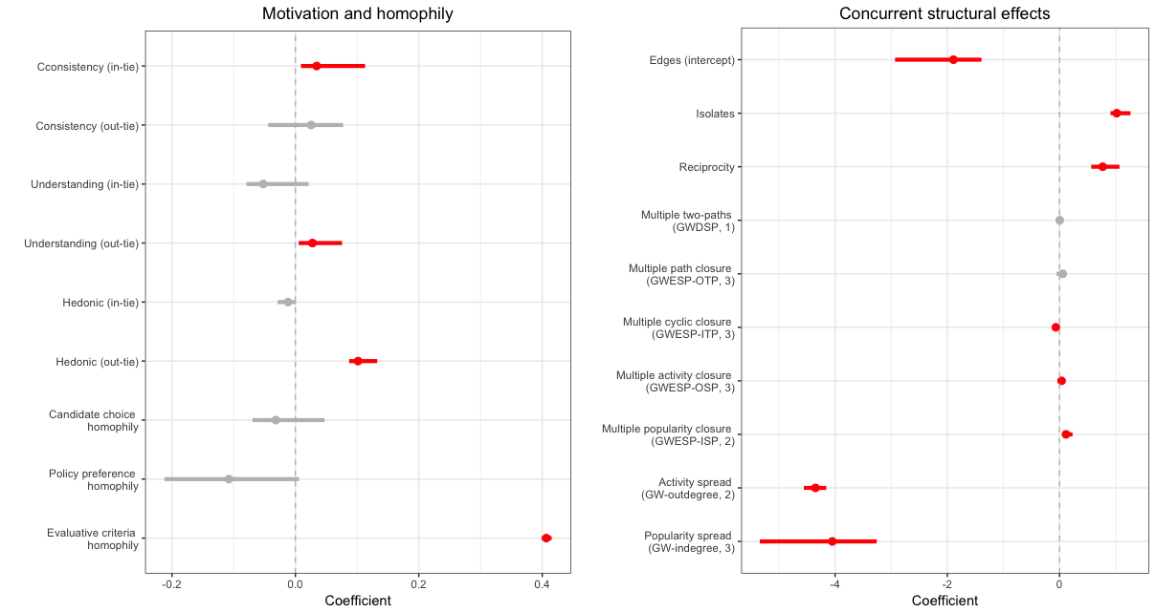

Panel B: Control variables

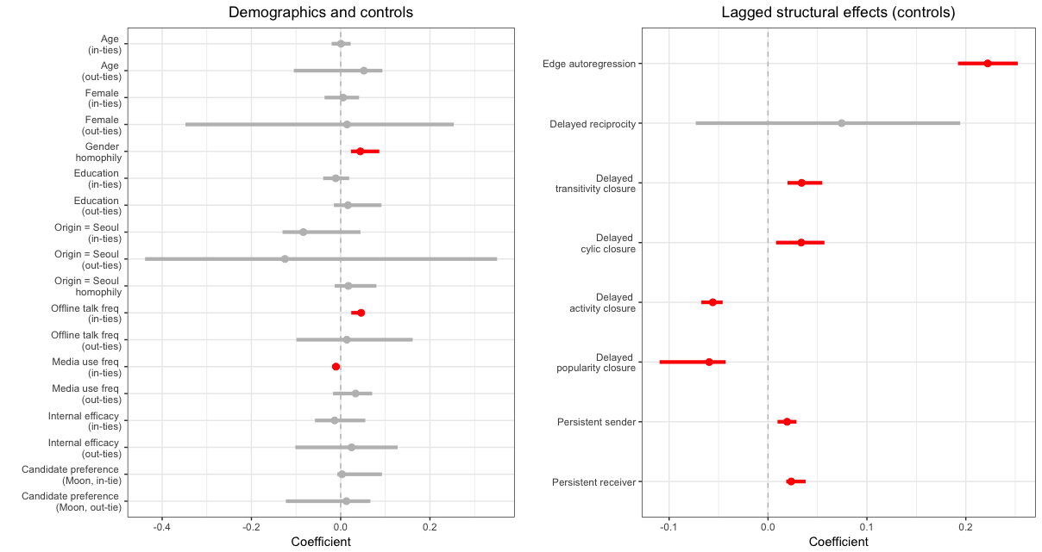

*Figure 1*. Parameter estimates and 95% confidence intervals from the final model.

Note. Significant model terms are denoted in red.

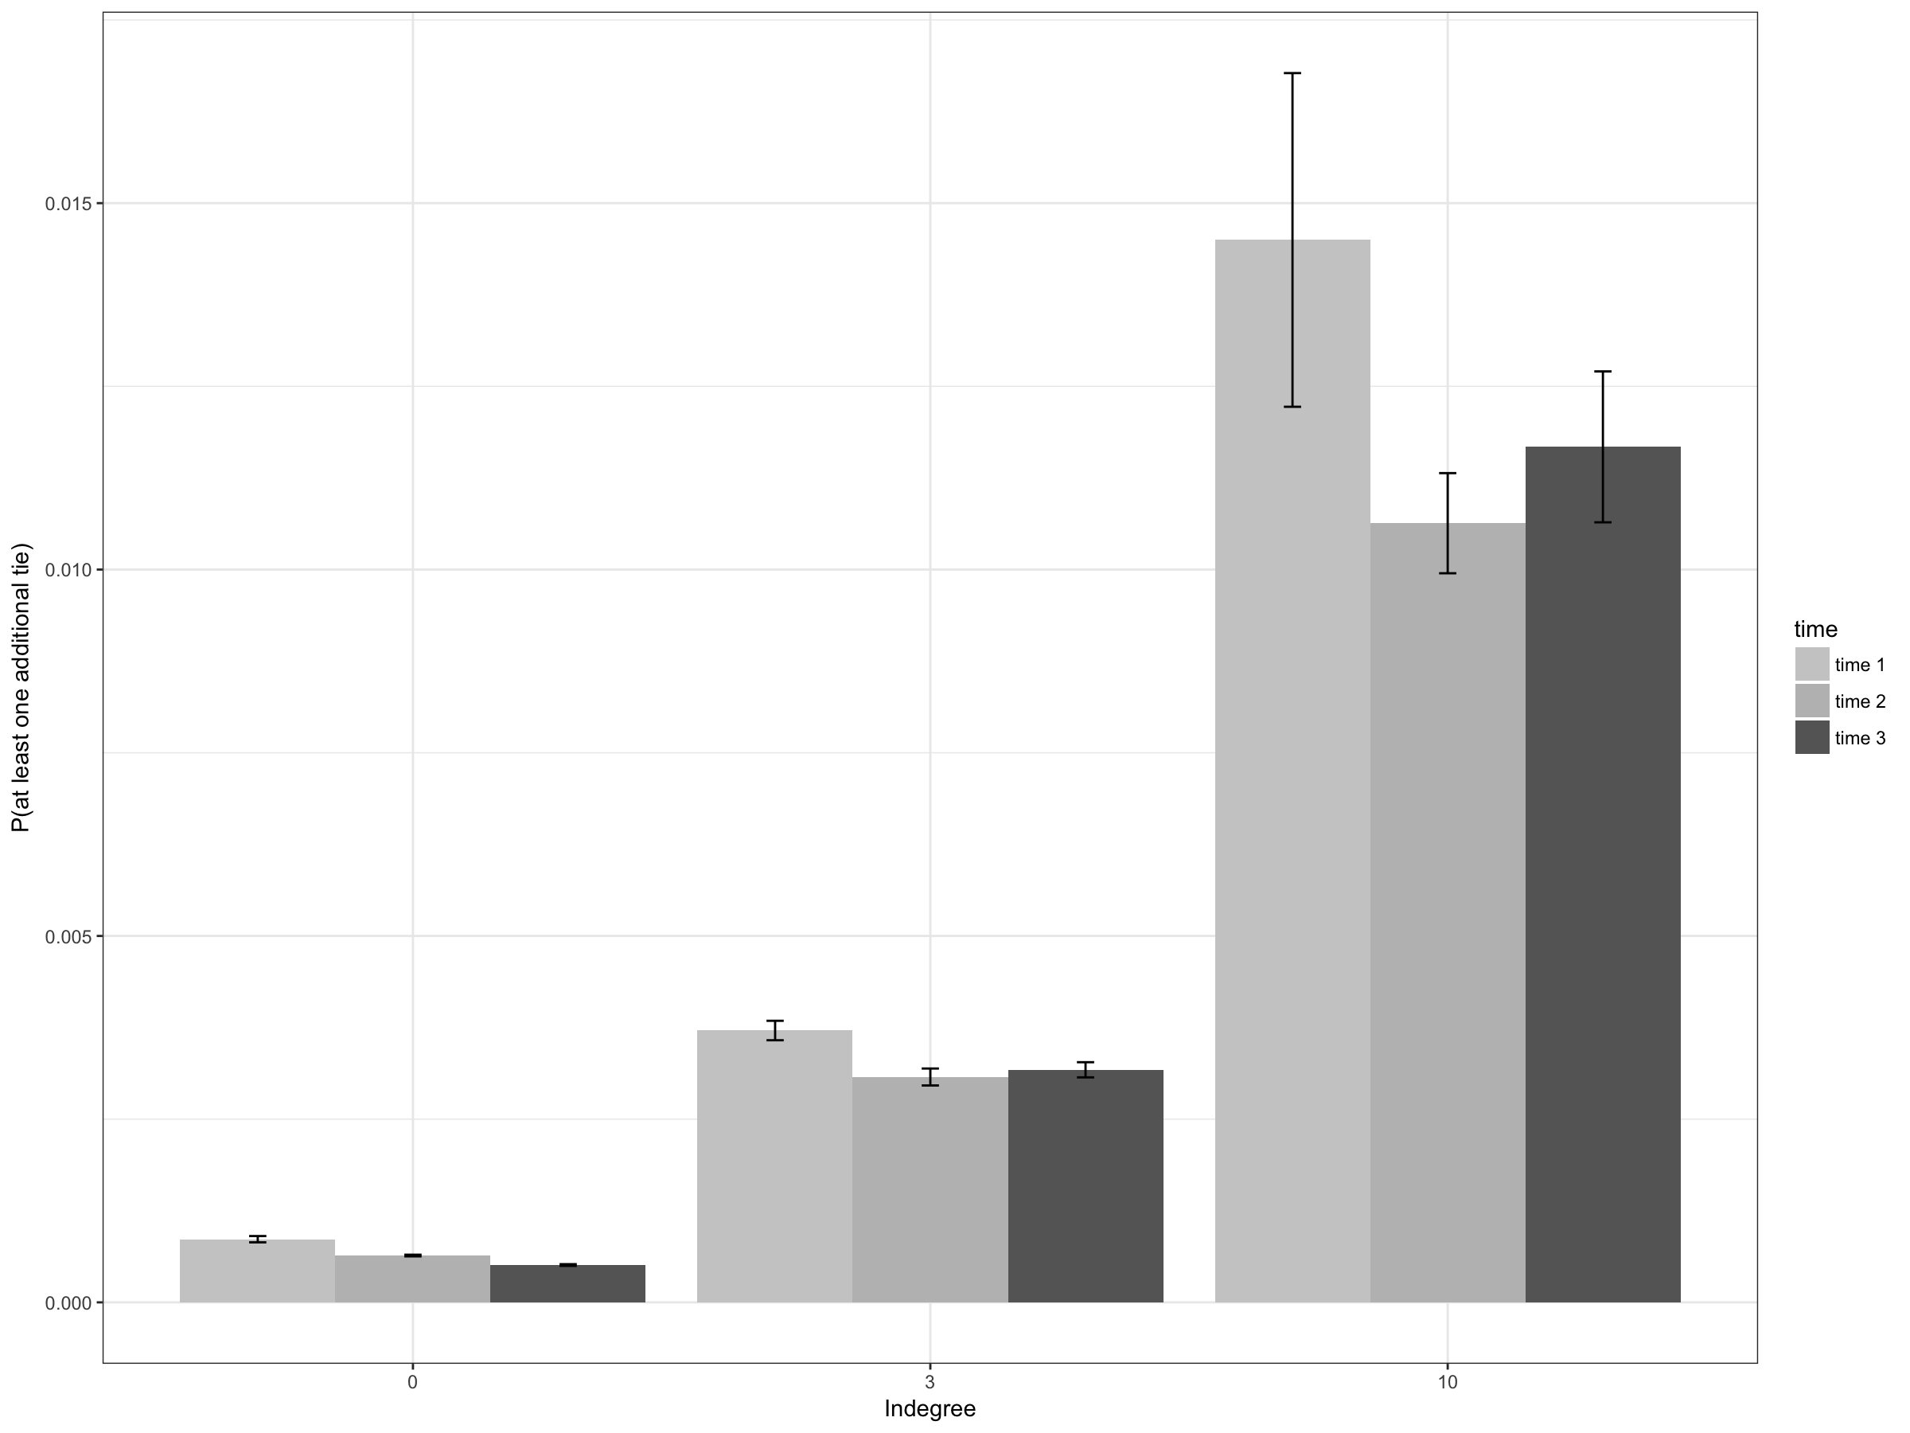

*Figure 2*. Mean predicted probabilities of *receiving* at least one additional tie (i.e., message being selected by others) as a function of existing incoming ties at 10% (zero), 50% (three), and 90% (ten) percentile of the in-degree distribution. Predicted probabilities are based on all eligible nodes of respective in-degrees. For each receiver node, we derived the mean edge probabilities of all other nodes (excluding any nodes that are already connected) sending a tie to the target node conditional on the rest of the network and on the model specification.

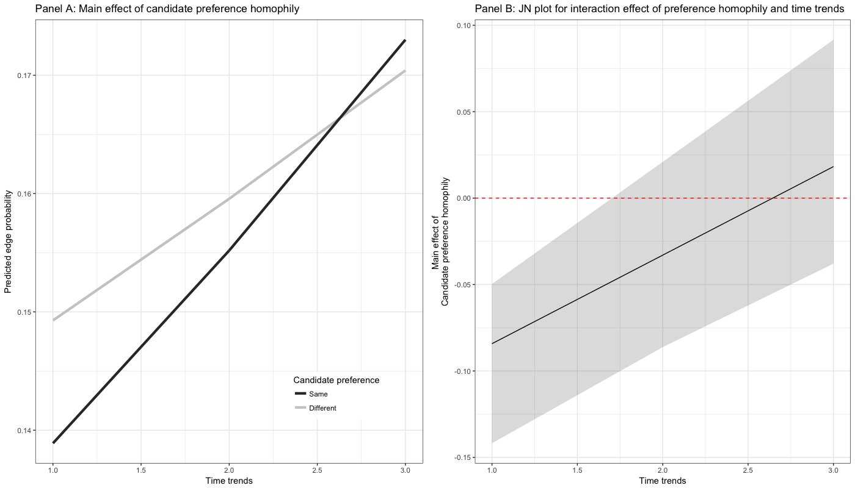

*Figure 3*. Interaction effects between time trends and candidate preference homophily. Panel A depicts conditional main effects of candidate preference homophily at each time point, and Panel B depicts Johnson-Neyman regions of significance as a function of time.

**Appendix**. Goodness-of-fit assessment for final model specification.

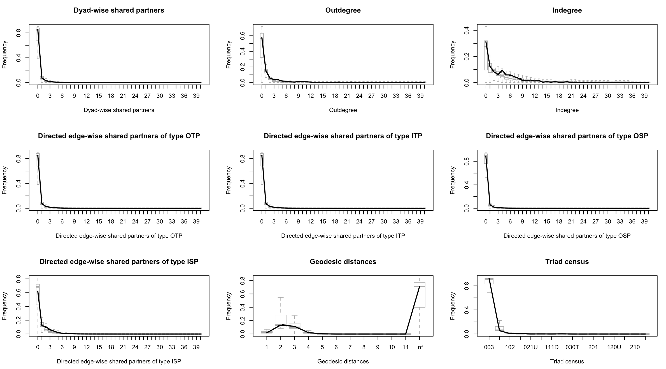

Note: The box-plots in light grey lines represent the 95% confidence intervals for each of the model configurations, and bold black lines represent observed network statistics for respective model configurations. The plot shows that all of the network statistics for our final model is within the acceptable range from the simulated distributions (for a detailed discussion of the method, see Leifeld, Cranmer, & Desmarais, 2017).

1. In ERGM estimation, any missing values on nodal covariates are not allowed. Yet an identical model with multiple imputation on candidate preference (imputation N = 5) yielded the substantially similar conclusion with the inclusion of those 22 missing cases.
2. Since participants’ key characteristics such as candidate evaluations and preferences were rather highly stable across survey waves, we assume participants’ characteristics may drive the creation of network ties (but not the other way around) provided that participants’ characteristics are relatively hard to be changed within such a short period of time.
3. Instead of partitioning the log data into three-wave panel survey dates (t = 3), we also estimated models with daily slices (t = 26) and found largely the same results with minor discrepancies in estimated coefficients and significance level. Combined with multiple imputation results, our robustness check suggest that our results and conclusions are reasonably robust against potential model misspecification and methodological issues.
4. Items include: “I am competent at presenting my own opinions in a discussion,” “I can express my ideas in a coherent manner,” “I make full use of my subject knowledge in a discussion,” and “I feel competent persuading others in a discussion.”
5. Although the effect of evaluative criteria similarity was more substantial between a dyad that share the same candidate preference (*b*interaction = .324, [.039, .466]), similarities in evaluative criteria had significant and positive impact on probability of message selection even among individuals with dissimilar candidate preferences.
6. The only important exception would be the situation where other (multiple) third actors leave visible traces (such as comments), and based on such visible traces, a given dyad choose to select each other’s messages. Yet this possibility seems to be an exception rather than common, and this does not necessarily contradict our conclusions.